
CS 111 – Programming Fundamentals
Assignment # 01
Program Structure, Operators, Type Casting, and Output Tracing

––
Student Name: Athar Imran
Student ID: 2604277

Assignment Date: 21st September, 2026
Assignment done: 22nd September, 2026
Due Date: 25th September, 2026
Contents
Question 1: Trace the Output 3
Part A: Arithmetic Precedence 3
Output: 3
Explanation: 3
Part B: Integer Division and Explicit Casting 4
Output: 4
Explanation: 4
Part C: Arithmetic Expressions and Formatted Output 5
Output: 5
Explanation: 5
Part D: Division and Remainder Operators 6
Output: 6
Explanation: 6
Question 2: Trace Programs with Given Input 7
Part A: Area Calculation 7
Input (given): 7
Output: 7
Part B: Time Conversion 7
Input (given): 7
Output: 7
Question 3: Find and Correct Common Errors 8
Correction: 8
Output: 8
Question 4: Complete the Basic C++ Program 9
Complete Program: 9
Output: 9

Question 1: Trace the Output
For each program, write the exact output and explain the operator rule that produces it.

Part A: Arithmetic Precedence
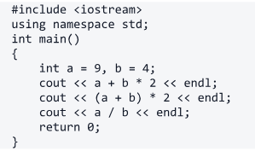
Code 1.1

Output:
17
26
2

Explanation:
After the initial code statements, it declares two integer variables, a & b. a contains 9 and b contains 4.
In the next line (a + b * 2), multiplication has higher precedence than addition; thus, b (which contains 4) is multiplied by 2 first, and the result is added to a (which contains 9). Finally, it prints 17 and endl, turning to the next line.
The next code statement prints (a + b) + 2; as per the BODMAS rule, parentheses are solved first, thus a + b is 13 and multiplying by 2 is 26.
Onwards, the code divides a by b, which is 9/4, and it gives 2.25. Here, in the code, a & b are integers; thus, the result will truncate the fractional part and only output an integer.

Part B: Integer Division and Explicit Casting
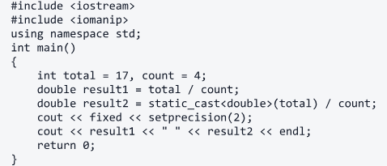
Code 1.2

Output:
4.00 4.25

Explanation:
The code declares two integer variables ‘total’ and ‘count’, giving values of 17 and 4, respectively.
Moving on, it declares a double-type variable ‘result1’, which divides total by count. That normally gives 4.25, but because both variables are integers, their fractional part is truncated, and since the storing variable is a double, this adds the part after the decimal: .22
Further, it declares another double called ‘result2’, and it also divides total by count, but differently. One of the variables in the operation is prompted to be statically cast, which converts 4 (int) to 4.00 (double). As the rule, if one double is operated with an integer, that integer gets promoted to double also. Finally, giving 4.25.
Before the conclusion, the code sets the format of the output as Fixed and SetPrecision(2).
Fixed displays floating-point numbers in fixed-point notation. And SetPrecision(2) forces exactly two decimal places after the decimal point.

Part C: Arithmetic Expressions and Formatted Output
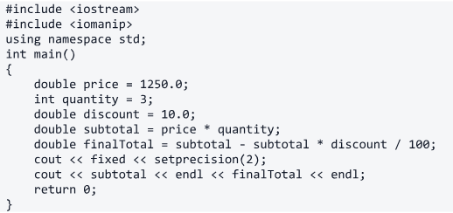
Code 1.3

Output:
3750.00
3375.00

Explanation:
Given is a double variable ‘price’ that has the value 1250.0. Then an integer ‘quantity’ with value 3. And another double ‘discount’ with the value 10.0.
Next up, ‘price’ and ‘quantity’ get multiplied and stored in double ‘subtotal’. 1250.0 * 3.0 = 3750.0. (As quantity int get promoted to double.)
Then, another operation is performed and stored in the double ‘finalTotal’. The operation performed is as follows:
- The ‘discount’ double is divided by 100 and becomes 0.10.
- ‘subtotal’ is multiplied by 0.10 and becomes 375.0.
- Finally, original ‘subtotal’ subtracts 375.0, giving 3375.00.
Next is the printing phase, same as explained above.

Part D: Division and Remainder Operators
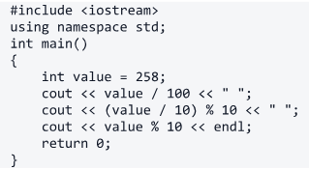
Code 1.4

Output:
2 5 8

Explanation:
An integer variable ‘value’ gets 258 and is printed with division of 100 and a space in between.
Then, the first 258 gets divided by 10 giving 25.8, while its an int, so it becomes 25. Which is in modulus with 10, giving 5. Remainder of (25/10).
In the last line, the value itself gets mod by 10, as 258%10. Remainder of 258/10 is 8 (int).

Question 2: Trace Programs with Given Input

Part A: Area Calculation
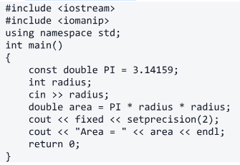
Code 2.1

Input (given):
5

Output:
Area = 78.54

Part B: Time Conversion
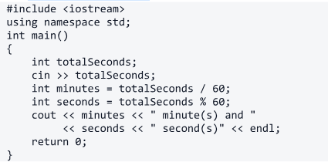
Code 2.2

Input (given):
367

Output:
6 minute(s) and 7 second(s)

Question 3: Find and Correct Common Errors
The program below contains five errors. For each error, write the incorrect statement and its corrected form.
Then write the expected output when the user enters 80.
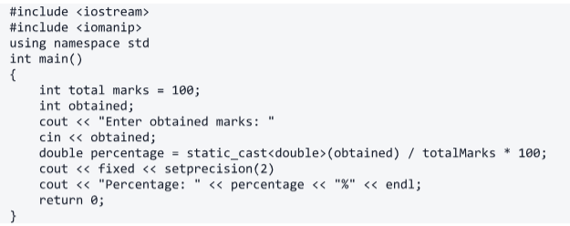
Code 3

Correction:
Line# | Error | Corrected
3. | using namespace std | using namespace std;
6. | int total marks | int totalMarks
8. | cout << “Enter …: “ | cout << “Enter …: “;
9. | cin << obtained; | cin >> obtained;
11. | cout << fixed << setprecision(2) | cout << fixed << setprecision(2);

Output:
Enter obtained marks: 80
Percentage: 80.00%

Question 4: Complete the Basic C Plus Plus Program
Fill in the five blanks and then write the exact output of the completed program.
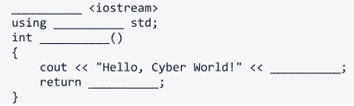
Code 4

Complete Program:
#include <iostream>
using namespace std;
int main()
{
cout << "Hello, Cyber World!" << endl;
return 0;
}

Output:
Hello, Cyber World!

